Handout – County Lines case study
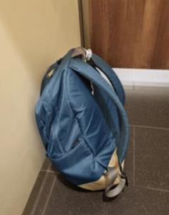
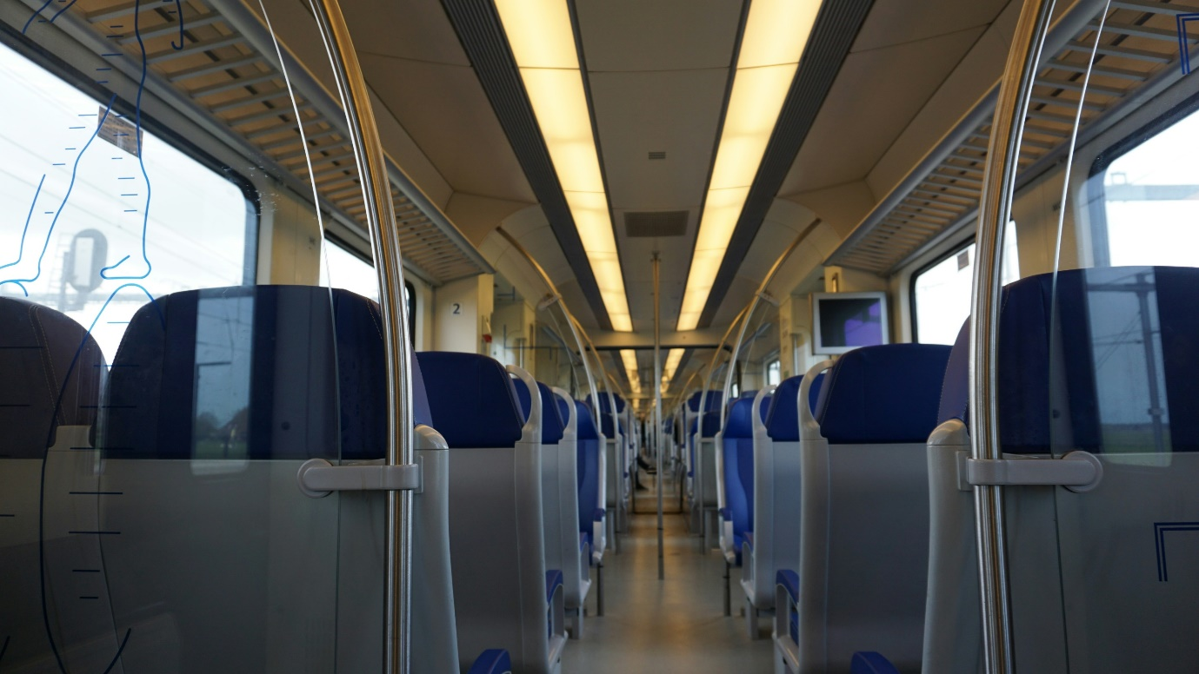Imagine that you are sitting on a train, it’s 8am and you have a backpack, you are wearing your school uniform and you are scrolling through TikTok on your phone. The ticket collector comes around to check your ticket, you pass it to him, he looks it over and moves on. To him you are just on your way to school, that’s what they were meant to think. You have missed weeks of schools this year already. They do not notice that you are tense, or that you are going a lot further on the train, past where you would get off to go to school. You have already been working for the last few hours. Soon you will arrive at your destination.

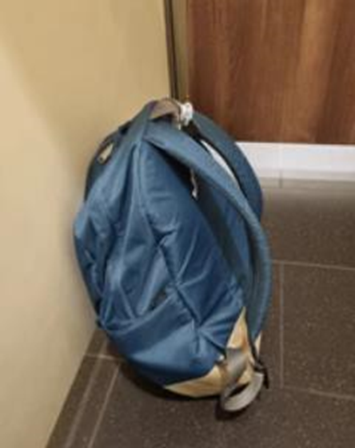
Inside your bag are not books or your sports kit. Your bag is full of class A drugs (those considered most harmful). Your boss has told you the address of the drugs den you have to go to. The amount of drugs you are carrying puts you in danger, you were told to carry a knife for protection. The fear of being arrested is a distant thought, as you walk to the house you’ve been told to go to. You must sell these drugs, if you do not make what you need, then you do not feel you can return home. Your boss threatened you, he knows where your family lives, so you do not argue. You met him on social media, he has bought you a lot of things, he promised to make you money, but now you feel like you owe him. Yes, you do make some money, but your life is now full of fear. You do not know who to trust or whether you will be believed, should you say what has been happening.
In pairs please discuss these questions, with one of you being able to feedback after a few minutes:
HOW WOULD YOU FEEL?
Do you think this could happen to you?
How could you make sure this does not happen?

