Exercise – how this relates to our everyday lives
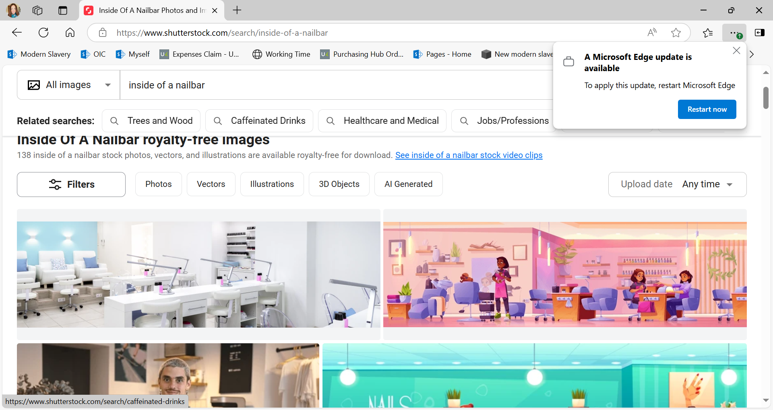

Narrative:
How many people go themselves or know someone that gets their nails done in a nail bar?
The people working in those nail bars are sometimes trafficked from countries such as Vietnam or Thailand with a dream to work in a nail bar or open their own bar one day. Instead, they find themselves and their families threatened if they do not do as they are told.
They may be sitting very quietly, not speaking, scared that they will get into trouble and thinking that no-one will believe them, should they speak out and say how they are being treated. Their reality may be very different to what was promised to them. Their wages may be much lower, well below the legal limit, they may be forced to live in cramped, damp and dirty living conditions, those exploiting them may be controlling them through debt they say they owe for the journey to the UK and they may be threatened with violence should they leave.
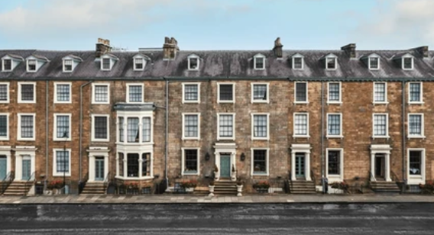

Narrative:
Take a moment to think about the person working in a house such as these above, not allowed to leave on their own accord. You have seen her looking out the window as you walk past, but you have never seen her leave. You are not sure how old she is; she may be quite young. She seems to always be in the house. Her reality is again, very different to what she was promised. She thought she was coming to the UK for a good job – to look after children as an au pair. Instead, she is forced to work long hours, cooking, cleaning and taking care of the children in the household. She is not allowed to eat with the family but instead is given scraps of food after they have finished eating. She must sleep on the floor in the kitchen. She is beaten if she complains. She did not think she would be treated like this, but this was always the plan for her according to her exploiters.
Q) How would you feel?
Q) How do you think people are tricked into this kind of work?

Buying Clothing Online Exercise
Q) Who has bought items of clothing online?
Q) Did you stop and think about where the items had come from, who had made them, in what conditions or why they were being sold so cheaply?
Boohoo facing modern slavery investigation after reports are revealed where workers in Leicester were paid as little as £3.50 an hour.

Narrative:
This was a headline from a story back in 2020 where the fashion company Boohoo was investigated after workers in Leicester making clothes linked to the brand, were found to be paid £3.50 an hour, far below the national minimum wage and also facing unacceptable and dangerous working conditions.
Q) What can we as buyers do differently?

